Assignment – 12

1) Write a query that selects all customers whose ratings are equal to or greater than any of Serres

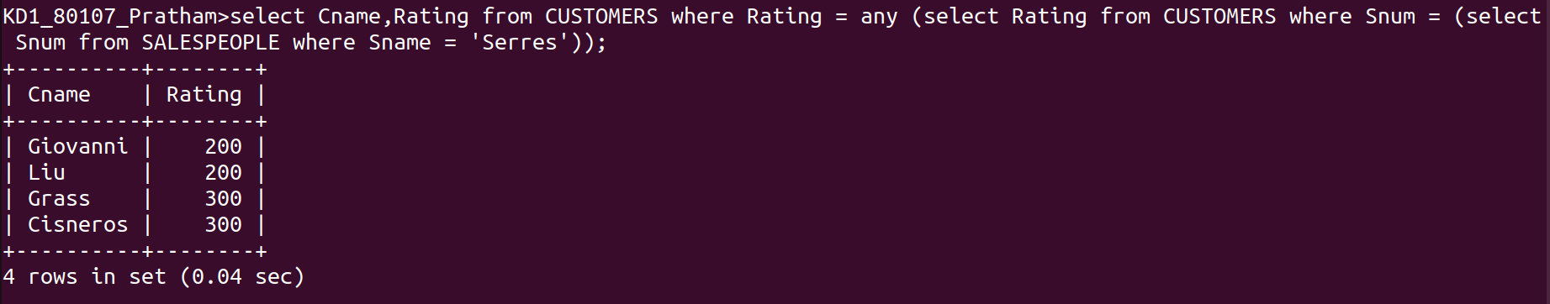

2) Write a query using any or all that will find all salespeople who have no customers located in their city

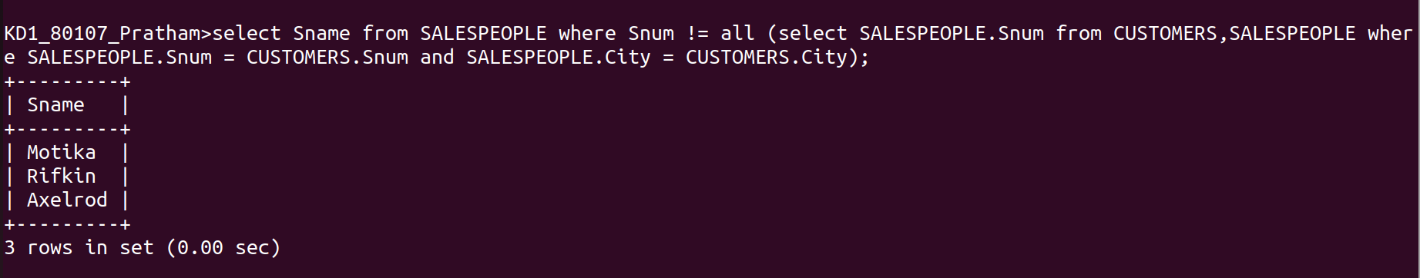

3) Write a query that selects all orders for amounts greater than any for the customers in London

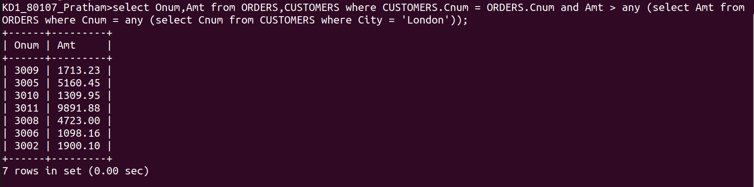

4) Write the above query using min or max

